

**Maharashtra Institute of Technology**

**(An autonomous Institute)**

**Project Title: Applicant Hiring Status Generation using UiPath**

**Objective:**

The objective of this project is to automate the process of generating a hiring status report from an Excel file, filtering applicants who have been hired or rejected, and generating a Word document with the details of hired employees in a table format.

**Project Workflow:**

1. **Reading Data from Excel:**
   * The bot starts by reading data from an Excel file that contains applicant information, such as name, position, status (hired/rejected), and other relevant details.
   * UiPath's **Excel Application Scope** and **Read Range** activities are used to read the data from the file into a DataTable.
2. **Filtering the Applicants:**
   * Using **Filter Data Table** activity, the bot filters the rows to separate the applicants who are "Hired" from those who are "Rejected."
   * The criteria are set to filter only the rows where the "Status" column has the value "Hired."
3. **Generating a Word Document:**
   * After filtering the hired applicants, the bot creates a Word document using the **Word Application Scope** and **Add Table** activities.
   * The hired applicants' data is then inserted into a table within the Word document, with columns for key details such as Name, Position, and Date of Hiring.
   * The table is formatted for readability, and the document is saved automatically to the desired location.

**Key UiPath Activities Used:**

* **Excel Application Scope**: To interact with the Excel file.
* **Read Range**: To read the Excel data into a DataTable.
* **Filter Data Table**: To filter applicants based on hiring status.
* **Word Application Scope**: To interact with a Word document.

**Benefits of the Automation:**

* **Efficiency**: Automating the process reduces manual effort and the chance of errors.
* **Consistency**: Ensures a standardized format for generating hiring reports.
* **Scalability**: Can handle large volumes of data and generate reports quickly

**Future Enhancements:**

* Adding the ability to automatically email the report to relevant stakeholders.
* Including rejected applicants in a separate section of the report for more comprehensive insights.
* Enhancing the Word document formatting, such as adding headers, footers, or company logos.

**Output:**

**Excel Sheet:**

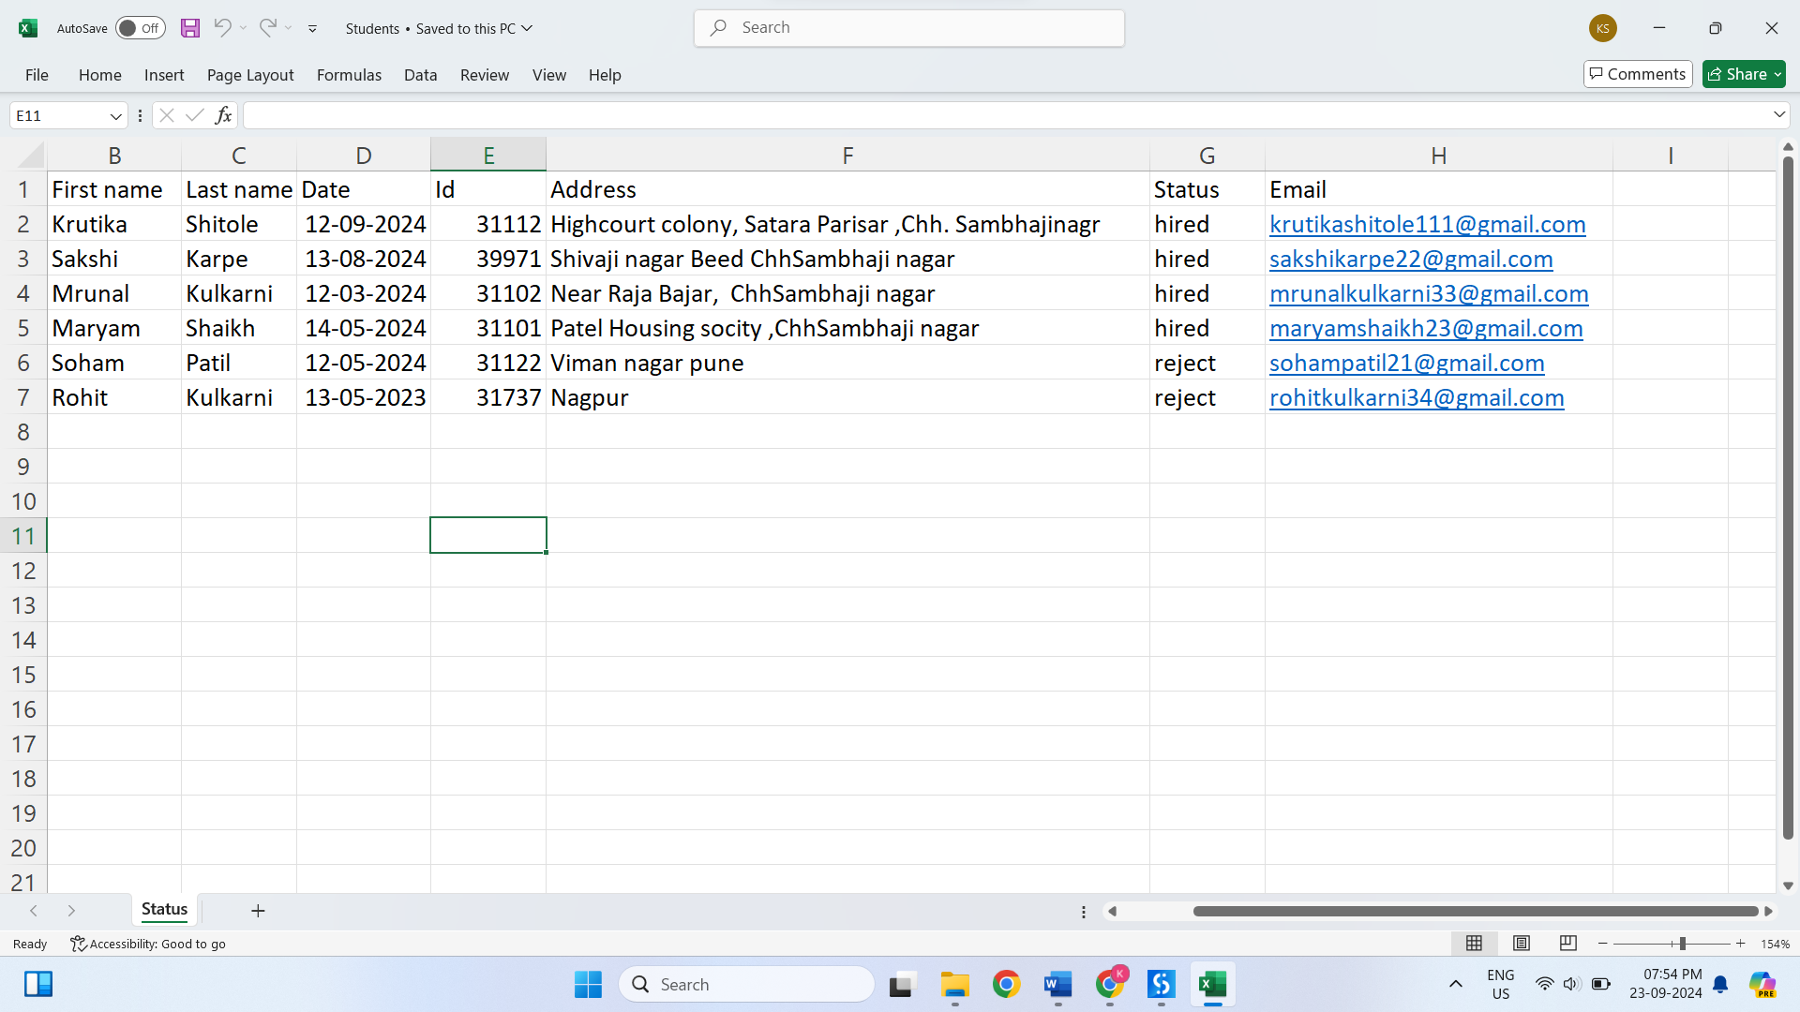

**Blank Word File:**

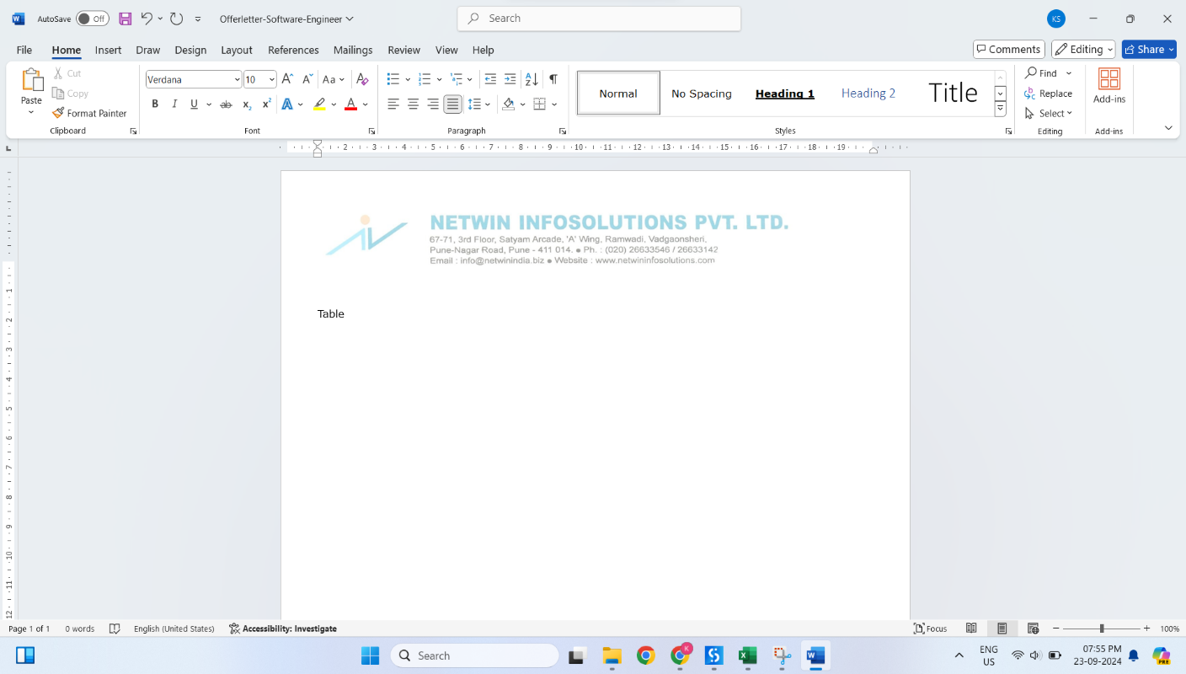

**Executing the process:**

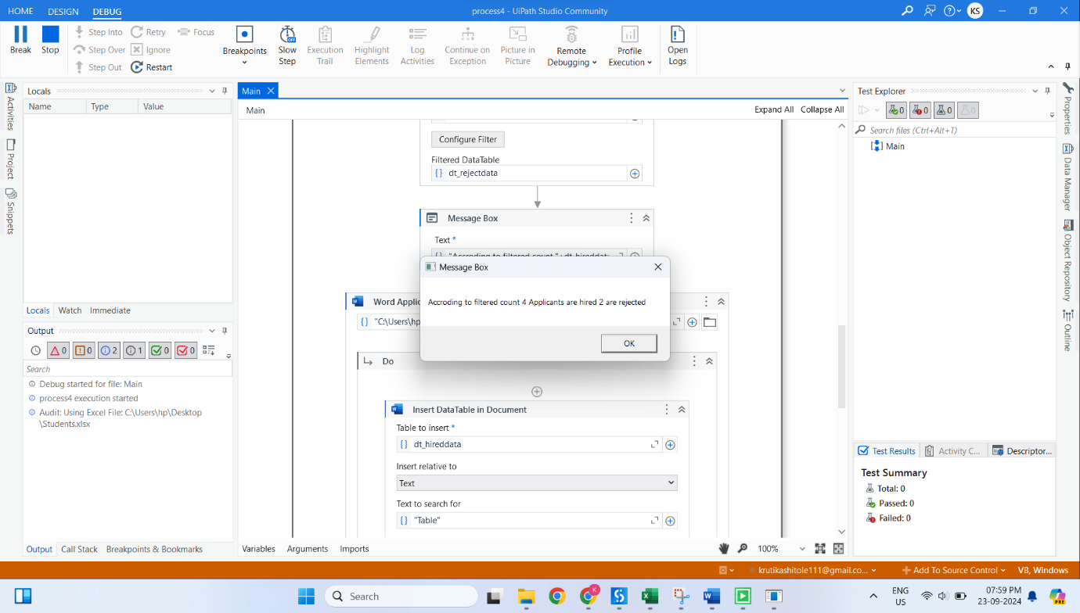

**Generating the status of applicant:**

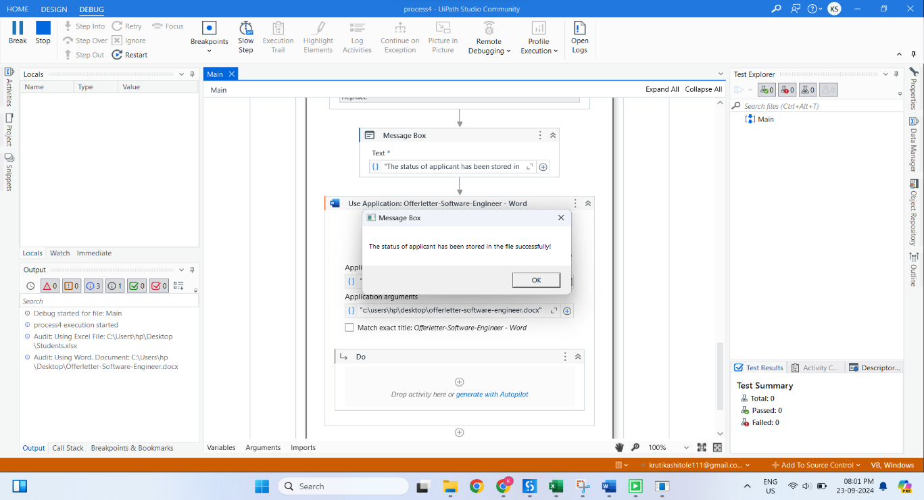

**Print the data of hired applicant in Word File:**

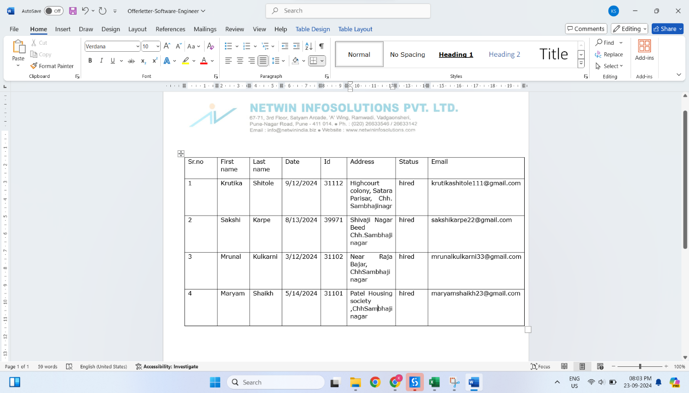

**Team Members:**

* Krutika Bhikan Shitole(TY CSE)
* Mrunal Makrand Kulkarni (TY CSE)